Group id : A6

Project Name : Stock Candle

**Assignment 6**

**Title**: Prepare Use Case Diagram of your project problem statement.

**Problem Statement:** Identify Major Use Cases, Identify actors. Write Use Case specification for all major Use Cases. Draw detail Use Case Diagram using UML2.0 notations.

**Theory :**

**UML Use Case Diagram**

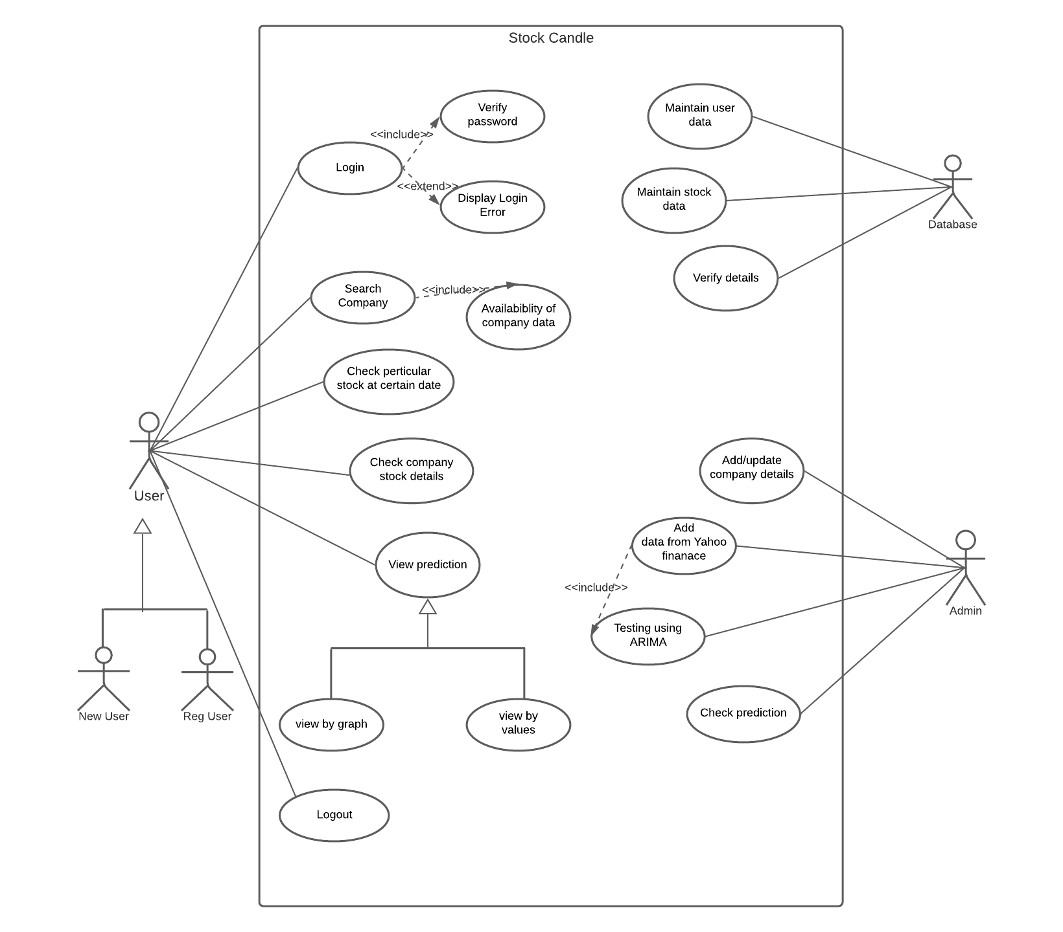

**Conclusion :** Thus, we have prepared uml use case diagram using advanced uml2 notations and lucid chart.